

West Coast Collaborative
Investigation 1 2016
Circles in the Complex Plane - Validation
Calculator but no notes allowed in the validation.
Name: _______________________________
Answer all questions in the spaces provided and provide full working to justify your answers.

Time allowed : 50 minutes Maximum marks = 29
- (2 marks)
From your work on the recent take home paper what two features are most relevant to the locus of points which are equidistant from two given points in a complex plane?
The locus of these points is a straight line √
which is the perpendicular bisector of the line segment joining the two points. √
- (1 mark)
Write the equation for a locus of points equidistant from two given points which is appropriate for a complex plane where the two points are A (a,b) and B (c,d).

√
- (6 marks)
Given that A is the point (3, 6), and B is the point (-4,3), on the grid paper provided, use a compass and pencil to sketch the locus. Mark 4 well spaced points on the locus and verify that distance from A = twice the distance from B. What is the locus suggested by your diagram?
The locus of these points is circle ( or circle is drawn on the graph) √
Points A and B are correctly represented and graph to consistent scale√
One mark each point, verified distance from A = twice distance from B either mathematically or by measurement √√√√
- (7marks)Using vector techniques and relevant diagrams, prove that the radius of the circle which is the locus of points that satisfy the equation , is given by the expression
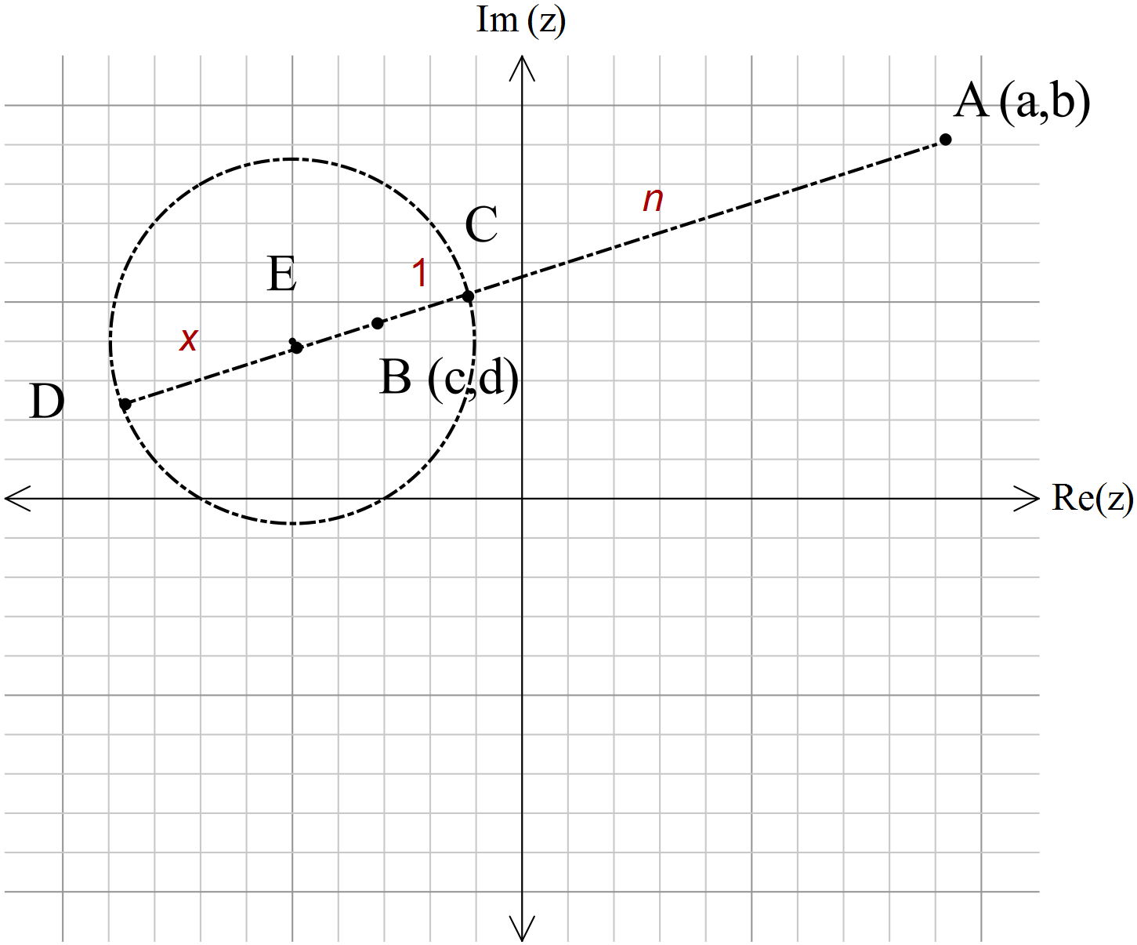

In the diagram shown E is the centre of the circle where C and D lie on the circumference.
The point C is n times further from A than from B.
Likewise D is n times further from A than from B.
If we make
Then √
√
√
So
√
√
Radius √ and √
√
5 (1, 4, 2, 3, 3 =13 marks)
For the situation described in question 3 above,
- Determine the exact distance between A and B.
= √
- Use the equation for r above, and the value of AB to complete the table below, rounding to 3 significant figures. (-1 mark max on this requirement)
 | r( radius) | (Actual)
0.01 | -0.0762 | -0.07616534759
0.1 | -0.769 | -0.7692700107
0.25 | -2.03 | -2.030872828
0.5 | -5.08 | -5.077182071
0.75 | -13.1 | -13.05561104
0.95 | -74.2 | -74.20496872
0.999 | -3810 | -3805.981657
0.9999 | -38100 | -38076.96149
√√√√ (half mark each)

- What happens to the locus of the circle as moves arbitrarily close to unity? In the limit, what is the shape of that locus?
The locus moves to the mid-point of AB √ and is a straight line in the limiting case. √
- What happens to the locus of the circle as increases? In the limit (as n approaches infinity) where would that locus cross the line AB, and what form would it take? The locus moves towards point B, √ remains a circle but with a radius decreasing to zero. √ In the limit the locus is point B. √

- What happens to the locus of the circle as moves gradually close to zero? In the limit (as n approaches zero) where would that locus cross the line AB, and what form would it take?
The locus moves towards A, √ remains a circle but with a radius decreasing to zero√ In the limit the locus is point A. √

